Create 3 files 1.txt, 2.txt, 3.txt. Add and commit to COMMIT1

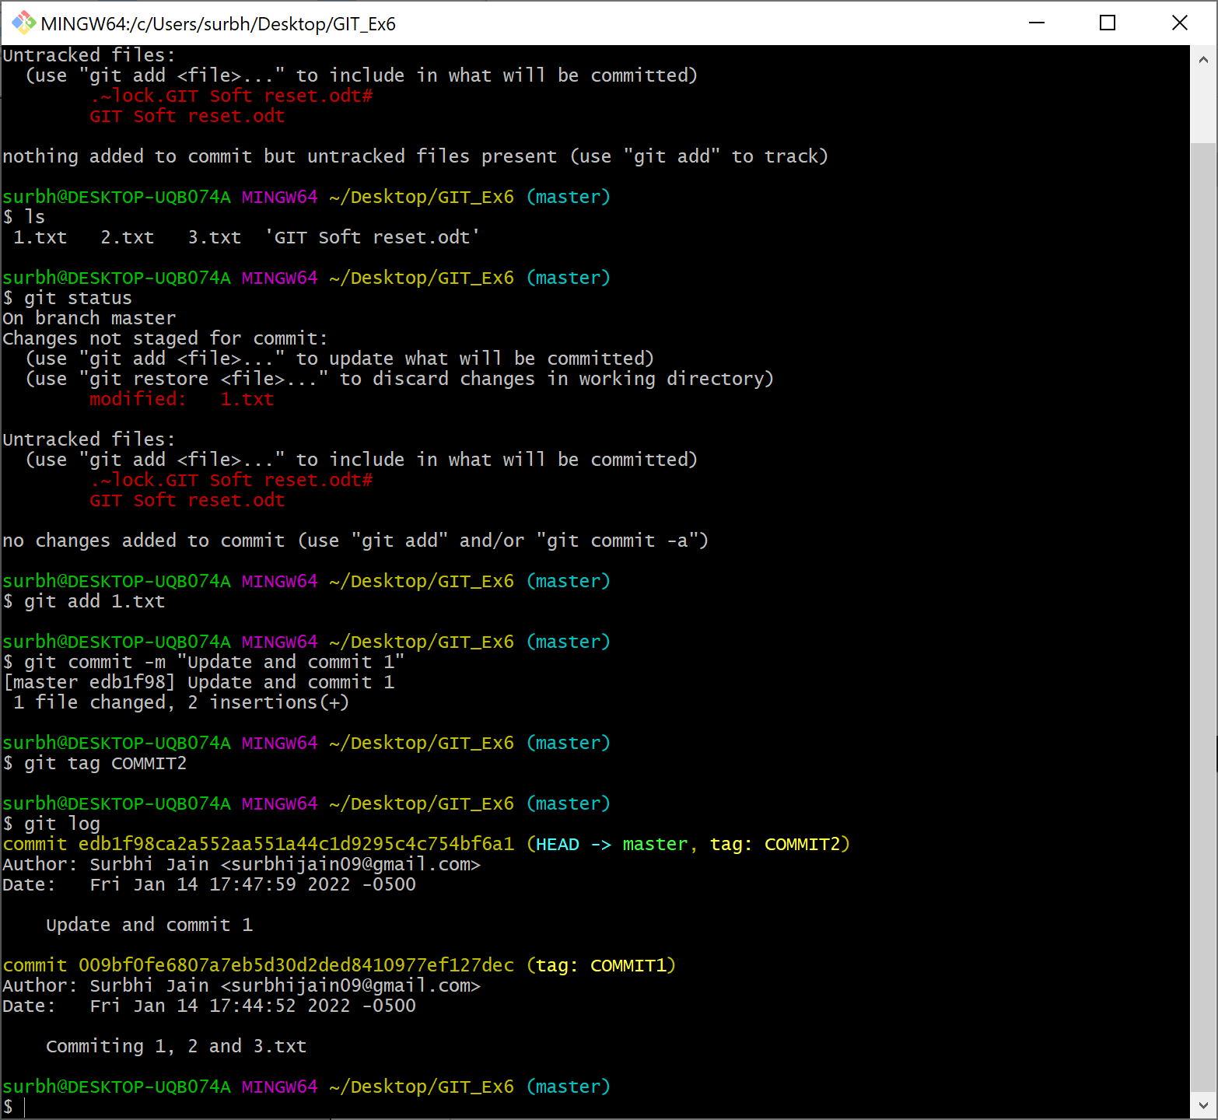

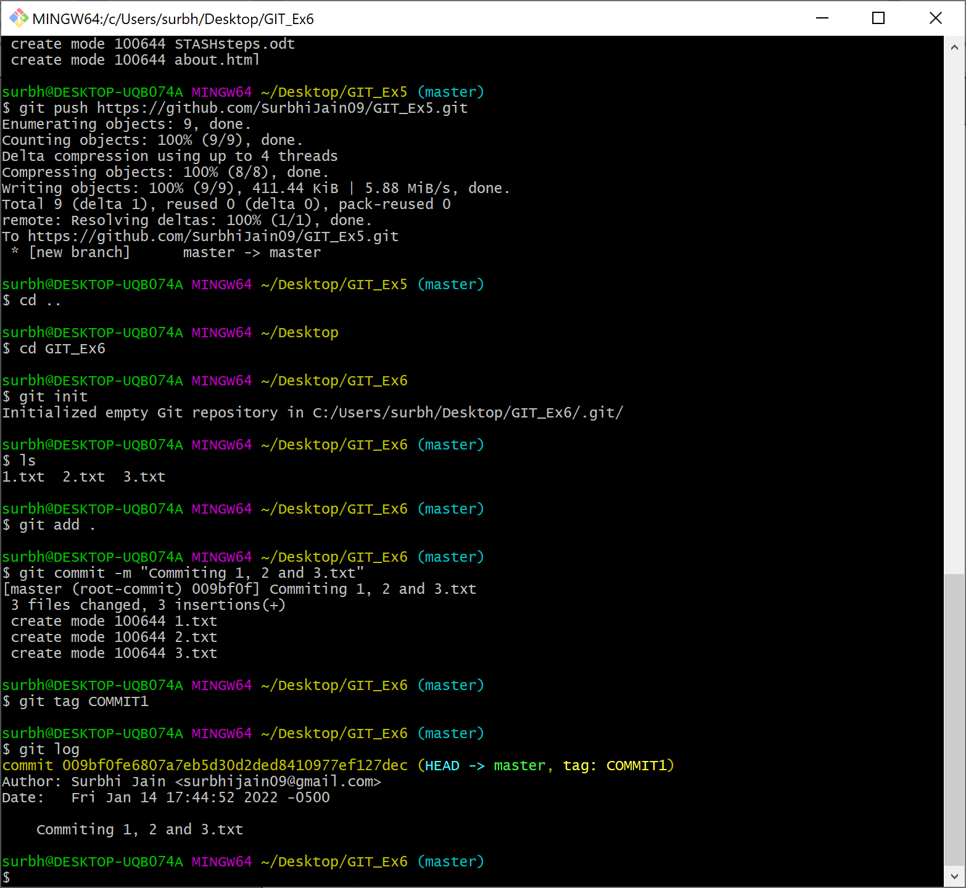
2. Update 1.txt. Add and commit with tag COMMIT2

3. Update 3.txt. Add and commit with tag COMMIT3. Git log shows all the commits.

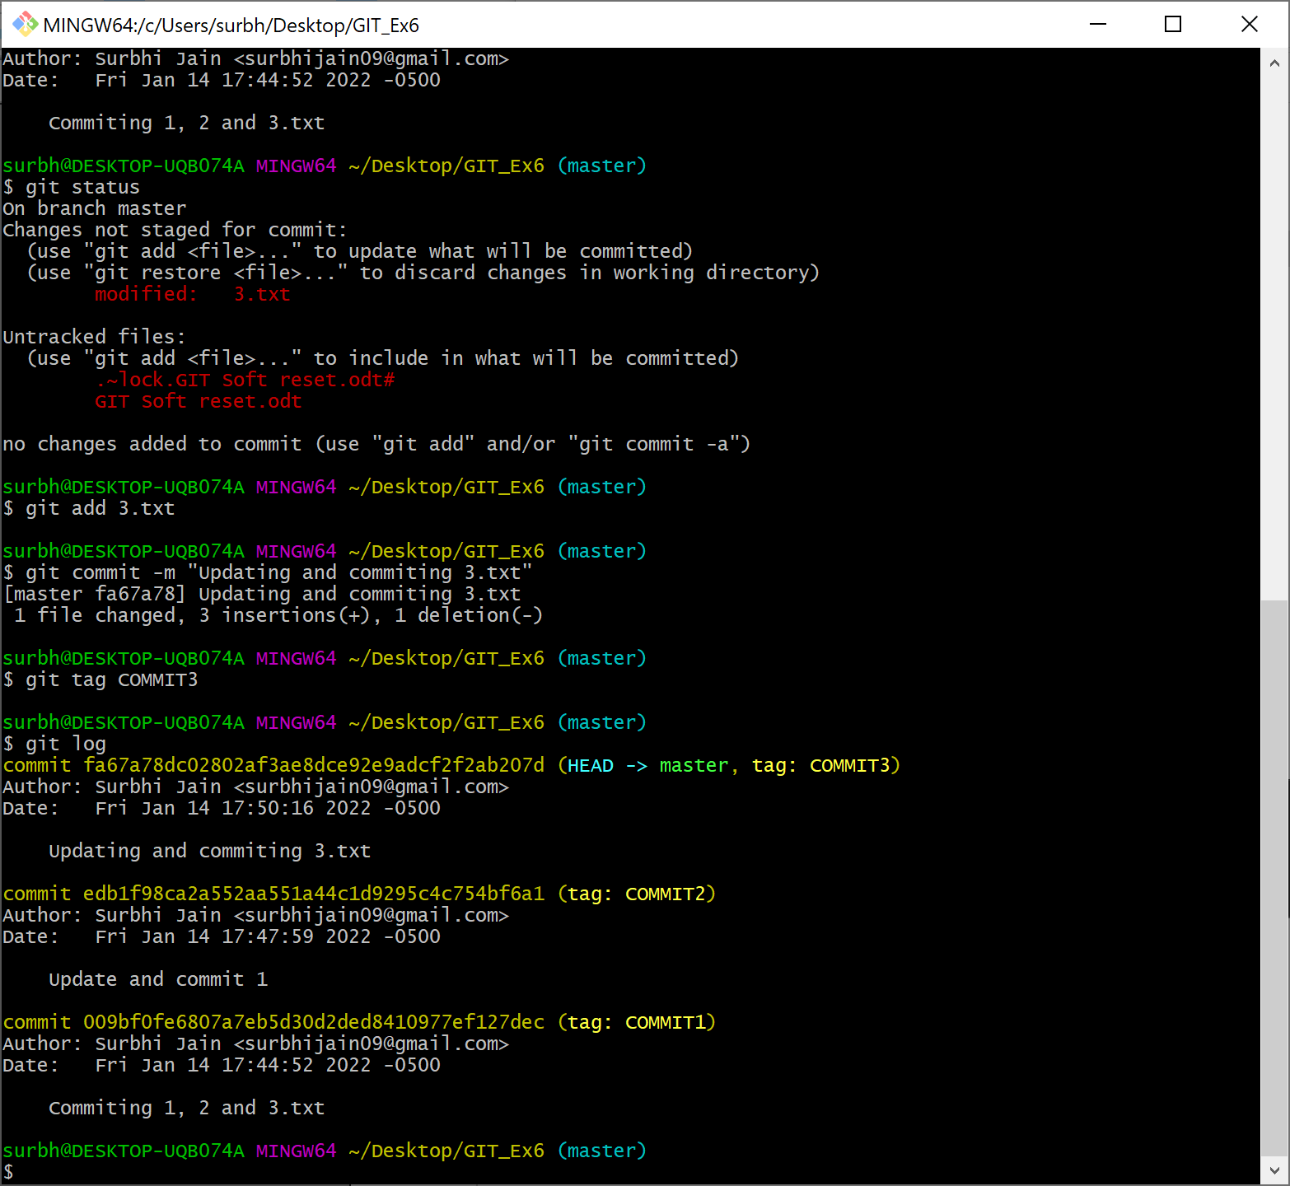

- If we soft reset to the Commit1, the changes on the files will remain same But the commits COMMIT2 and COMMIT3 will be removed.

